Keywords:
Lead Generation Services, Lead generation agency Dubai, best lead generation agency

Meta Description:
Lead generation is a technique of finding the right people who are interested in your products and services. Read and learn how to make this happen.

Step-by-Step Guide to Lead Generation: Everything You Need to Know
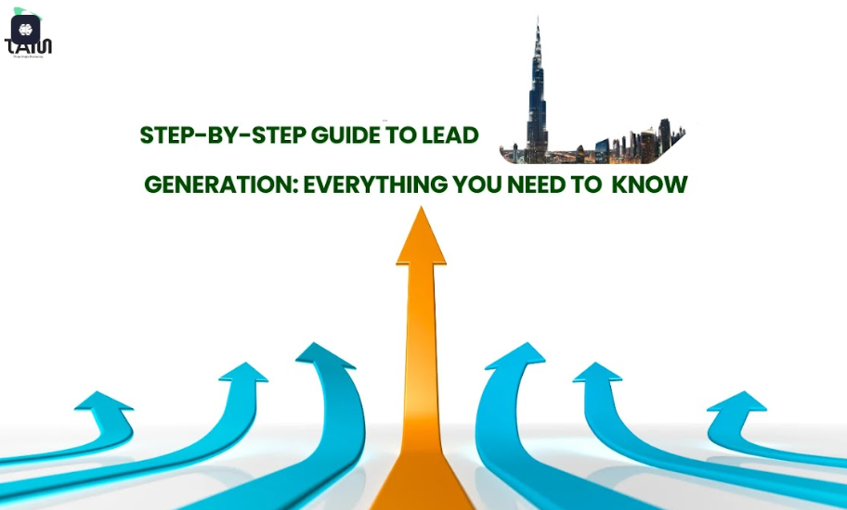
Customer acquisition is one of the critical priorities of a business in the rapidly growing area of Dubai, UAE.
As competition becomes more and more intense, there is always a great demand for organizations to target their audience effectively and turn them into consumers.
Lead generation is, in fact, not an easy process because every step of it has a different story to tell and a different narrative to build.
Here in this blog, we will educate you about lead generation and every problem associated with it.
Moreover, we also guide you by providing all relevant information about lead generation tools, strategies and insights to help you navigate effectively.
We have you covered, whether it is the identification of the right audience for Lead generation Services or converting that audience into potential sales.
Let’s discuss in detail how you can grow your business effectively by transforming your lead generation approach effectively.

What Is Lead Generation?
Lead generation is a technique of finding and cultivating people who have the needs and requirements for your products.
Most of the time, lead generation tactics target that audience who are possibly interested in your line of products.
It involves the identification, nurturing and conversion of prospects so that they fit into your sales cycle.
It is simply to collect information and determine the level of interest to pave the way for other sales-related occurrences.
For instance, think about a Lead generation agency Dubai that deals with real estate. It offers property valuation services to attract buyers and other people interested in selling their properties. In return, they get to access contact details, which they give to the sales department to generate leads.

Why Is Lead Generation Important for Your Business?
Let’s understand the significance of lead generation and why it is so important for your business in Dubai’.

Drives Sales and Revenue Growth
Lead generation is the most vital process in the sale cycle of an organization that wants to expand its market.
In this way, you can create a strong foundation in terms of generating interest from your potential customers, which may result in high sales and income.
It is not only a matter of finding new clients and consumers but also a matter of retaining the clients and consumers and making them loyal.
As much as there is cutthroat competition in Dubai, where companies are known to be very innovative and customer-oriented, the best lead generation agency in Dubai will prove useful for your business. It enables you to have a constant flow of potential customers to your business and ultimately eliminates dry seasons for your business.

Building a Sales Pipeline
The sales pipeline is important in the formulation of a strong plan that would help in the growth of a business venture.
In this regard, lead generation is instrumental in ensuring that a steady stream of compared leads is available for your salespeople to engage. Competition in the Dubai industry has been on the rise, and having a fully covering sales pipeline would prove very crucial for any firm in Dubai.

Enhancing Brand Awareness and Customer Trust
Apart from counting the leads, lead generation is more about making a connection that your business is going to have with a particular target market.
Through targeted campaigns in lead generation, the target customers are created and trusted, ultimately increasing the bond of the business.
Since the culture of the target audience and their expectations differ significantly in Dubai, general lead generation can be one of the most effective techniques to engage potential consumers.
It is about building relationships and experiences that will make an impact, resulting in brand awareness and recommendations.

How Does the Lead Generation Process Work?
Let’s discuss exactly how the lead generation process works:

Identify Target Audience:
Concerning the strategy of setting up the organization, the first thing is to make sure that you understand the target segment.
In the context of Dubai, diversity is a major factor that determines customer segments' needs and wants.
You can survey the market to determine what your target customers are in search of and what factors might hinder them.

Attract Prospects:
Secondly, apply several approaches to attract potential contacts. In this regard, content marketing, social media, and SEO are effective in Dubai.
This way, you get more attention from people who may possibly be interested in your posts through social media platforms such as Instagram and LinkedIn.

Engage Leads:
Keeping leads interested is crucial. It is easy to keep their interest level high through newsletters, free resources and other related content.
Competition has become cut-throat in Dubai, and anything that can be offered that is useful to the prospects is what will make someone return.

Convert Leads:
Last but not least, retain customer’s data and change them into paying customers.
This is based on factors like follow-ups, proving the value, and the likes.
In essence, greater self-awareness of the customer and improvement of his/her relationship with the customer would definitely make a lot of improvement to the rate of conversion in Dubai.

What is Lead Generation Funnel:
To understand lead generation effectively, you need to understand the lead generation funnel first.
This funnel approach tells us how to generate leads effectively. It involves a three-stage process, which is the top, middle and bottom lead generation funnel. Let’s understand each stage of the funnel for better clarity.
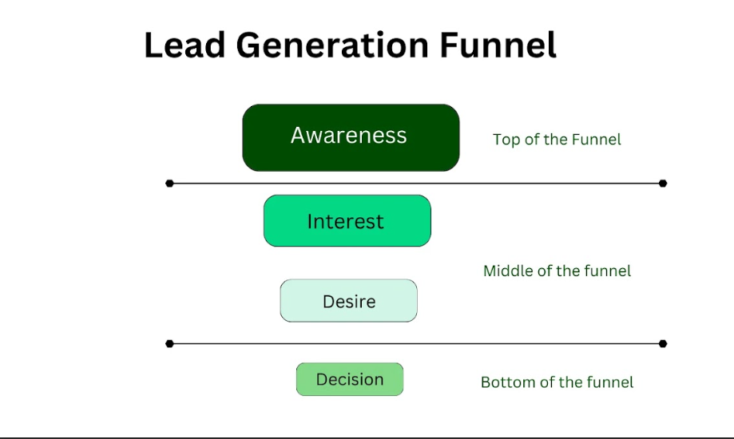

Top of the Lead Generation Funnel:
The awareness stage is at the top of the lead generation funnel.
In this stage, leads are created by raising awareness about your products and services.
This stage covers the aspect of visibility whereby the company seeks to make the brand famous. In this location, where there is great competition in the business world, visibility is crucial.

Strategies to Fill the Top of the Funnel:
When you are going to use the funnel analogy, we suggest that you fill the top of the funnel.
This can be done by sharing posts on blogs, advertising, and good engagement on social media platforms. All these strategies are useful for enhancing digital presence in Dubai as the site of focus as this is an essential factor associated with the broadening of the audience.

Middle of the Funnel:
It is important to remind the leads in the middle of the funnel of the knowledge they are gaining and the nurturing of the leads.
Additionally, addresses all the issues that are important to them and keeps them interested.
Moreover, ensuring the ability to provide valuable insights to clients where businesses are always on the lookout for innovative solutions is critical.

Techniques for Engagement:
Further, it is advisable to interact with the leads through the use of webinars, case studies, and other unique forms of content. When it comes to obtaining and retaining customers in Dubai, where the market is defined as fairly competitive, providing customers with job vacancy content that is different from what every other company offers and is valuable might not be very difficult.

Bottom of the Lead Generation Funnel:
On the ‘bottom’ of the funnel, the leads are likely to make a purchasing decision.
That’s why there is a need to employ specific measures aimed at conversion to occur during this stage.
Moreover, also takes into consideration all factors that can affect the purchasing decisions made by consumers in Dubai.

Strategies for Conversion:
To influence the leads to convert to clients, engage them with personalized offers, consultations and reminders.
Most of the time, you will see people in Dubai prefer a personal approach to products and services. That’s why the usage of a product greatly contributes to improving conversion rates.

Types of Leads: What Are They?
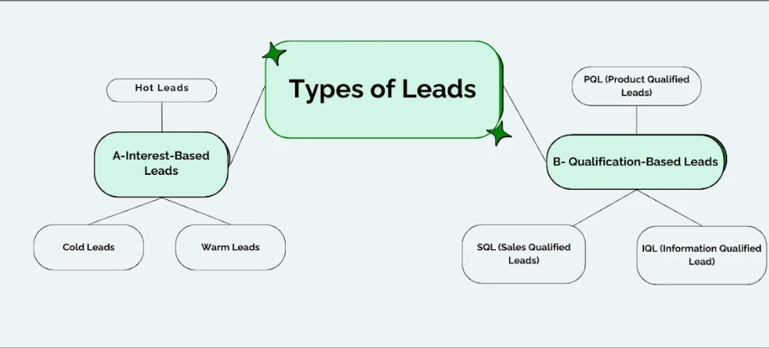

A. Interest-Based Leads
Interest-based leads are generally divided into three major categories, which are hot leads, cold leads and warm leads.
Let’s have a better understanding of each of them by discussing them in detail one by one.

Hot Leads:
Hot leads are implied to those prospects who are highly interested in making a purchase.
Having realized that time is of great essence in Dubai, follow-up of such leads should ideally be done swiftly to help the organization capture the leads immediately and convert them to clients.

Cold Leads:
Cold leads do not exhibit any interest at all.
In Dubai, with adequate content, these leads may be gradually cultivated to convert them into better prospects.

Warm Leads:
These are individuals who have demonstrated some level of interest in the offering, but they still require further encouragement.
In Dubai, you can rely on highly engaging and compelling content to provide information that brings them to the next level of the funnel.

B. Qualification-Based Leads:
Qualification-based leads are typically divided into four major categories, which are SQL, PQL, IQL and MQL. Let’s discuss each for better understanding:

PQL (Product Qualified Leads)
PQLs are people who used your product and made inquiries of intent regarding the product being marketed online.
In particular, the following leads are closer to conversion in Dubai, where matters of trust and quality are of extreme significance.

SQL (Sales Qualified Leads)
SQLs have the approval of the sales team, and all the SQLs are more stable for direct selling efforts.
In Dubai, it is efficient to develop these leads to realize the maximum sales production.

IQL (Information Qualified Lead)
Different IQL prospects have interacted with your products or services for the purpose of gaining information.
In Dubai, where information is critical, it is possible to continue feeding these leads with more information to advance them to the next stage of the funnel.

MQL (Marketing Qualified Leads)
Such prospects are considered to have a higher threshold of converting as they are identified by marketing initiatives.
In Dubai, these leads are very useful as those who visit marketing channels are already interested.

How to Determine the Quality of a Lead?
Lead scoring categorization is a significant aspect since it helps in the identification of ideal prospects on whom to spend resources.
Quality leads in terms of Sales have a higher likelihood of being converted into Paying customers.

Criteria to Evaluate Lead Quality:
If you are considering evaluating the quality of the lead, here are some factors you need to consider.

Target Market Compatibility:
Determine if the lead corresponds well with the demographic target market. These are age, location, job title and some of the other features that can be incorporated into designing this set of models.

Engagement Level:
Evaluate the frequency and depth of interaction with your brand. High engagement gives a suspicion of deep interest in your products and services.

Understanding of Buyer’s Journey:
It is important to understand the stages of the buyer’s journey. It assists in aligning your lead generation efforts to the needs and stage of the buying process of the customers. When properly targeted and properly done, potential clients are far easier to guide to the state of conversion.

What is the Lead Scoring Model?
The lead scoring model is a method that involves rating the leads based on a decided set of characteristics.
This model is useful for filtering the leads for follow-up and does not let the sales department lose its attention on those leads that may have high conversion rates.

Purpose of Lead Scoring Model:

Lead scoring has the advantage of helping in the proper allocation of resources in an organization.
By quantifying the lead potential, you will be in a position to approach the higher-scoring leads that have better probabilities for conversion.

Components of the Lead Scoring Model?
Here are some major components of the lead scoring model that you should consider:

- Demographic Information: Consider factors like age, location, and job title. Having points that match the demographic within your target market yields more leads.
- Action data: Monitor visits, opens, downloads, and other forms of behavior data like watching a video or abandoning a shopping cart. The following are some behaviors that can be deemed indicative of a lead’s level of interest.
- Interactivity: Assess the degree of activity and interest. This reiteration is more likely because people who interact frequently are likely to make the switch at some instance.

How to Create a Lead Scoring Model?
A lead scoring model comprises the following steps:

Develop Profile:
Devise your Ideal Customer Profile that is, the customers that bear the characteristics of the best customers.

Assign Scores:
Establish a scale for assigning points to different fields, including demographic suitability and activity level.

Guidelines:
Find out acceptable scores that indicate leads to be positioned as hot, warm, or cold.

Test & Refine:
Monitor the effectiveness of the designed model and adapt it in case of necessity.

Tools and Software for Lead Scoring:
Some of the tools that may be useful while lead scoring are Customer Relations Management systems such as Salesforce and Hubspot.
Such platforms have functionalities to score the leads and monitor further engagement on the leads.
How to Generate Qualified Leads? (Lead Generation Strategies)
There are two main ways to generate qualified leads in Dubai: one is through outbound lead generation strategies, and the other is outbound lead generation strategies.
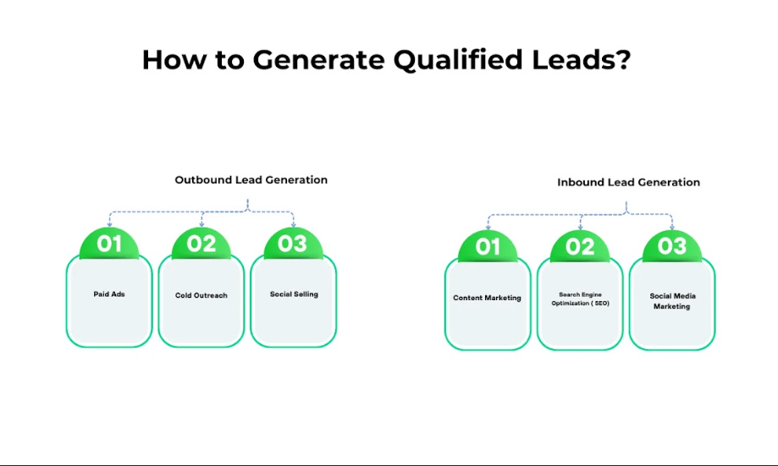

A. Outbound Lead Generation and Its Strategies

Internet Advertising:
A company can use paid advertisements such as Pay-per-click (PPC) and other display adverts. Market the product through advertised packages via the age, gender and other interests of potential clients.

Email and Calling:
Cold emailing and calling identify the type of communication approach to use while conducting an initial communication. Build your communication and promote custom messaging and the use of data.

Social Selling:
Engage with leads on social media platforms. This dictates the sharing of high-quality content and active involvement in online conversations for the purpose of creating a good rapport.

B. Inbound Lead Generation and Its Strategies

Content Marketing:
Provide the audience with content that would be informative and useful to them in one way or another. Blog posts, eBooks and webinars could be used in order to attract potential leads.

Search Engine Optimization (SEO):
As an effective technique for enhancing website traffic, one should employ SEO meaning of SEO on the website. When the page is written, there is a use of relevant keywords and metadata tags for the purpose of attracting organic visitors.

Social Media Marketing (SMM):
Build a strong brand presence on social media. Post on the page’s cover and walls, reply to comments, & send messages to fans in order to capture the audience’s attention and gather leads.

Conclusion
Lead generation in Dubai, UAE, is a dynamic process that helps in the growth of the enterprise. Therefore, it is possible to improve lead generation by knowing the usual obstacles and providing the corresponding solutions. That is why at Three Angle Marketing (TAM), the leading Lead generation Services in Dubai, we are keen to ensure that we assist you to overcome these difficulties and realize your goals. Follow the above approaches, and you shall notice the lead generation process benefit in the market of Dubai.

